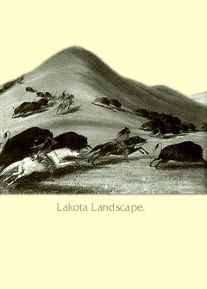
LAKOTA (SIOUX)
Sioux means "Lesser Snake" in Chippawa. They call themselves Lakota, which means "friend." The Lakota lived on the plains with many other Indians like the Cheyenne and Oto. On the plains they survived by hunting buffalo and following the herds from place to place. Today the Lakota have reservations in North and South Dakota and Montana.

LAKOTA CLOTHING
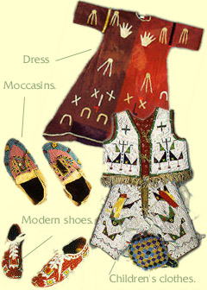
Clothing is made beautiful with bead work and designs meant to honor the spirit world. Traditionally they were made of buckskin and elk skins. Women wore dresses and leggings and men wore shirts and breechcloths. In cold weather, they wore buffalo robes. Infants were placed in cradleboards for protection.

BUFFALO
The buffalo gave people everything they needed to survive and was considered a Spirit Being. Buffalo meat provided food, the pelt clothing and the bones tools. The buffalo is central to the traditional religion of the Lakota and neighboring tribes. Tutsi Wai BigBee, a Comanche, talks about the importance of the buffalo.

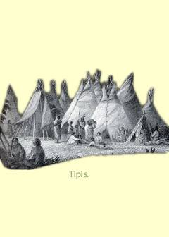
LAKOTA TIPIS
The Lakota (Sioux) called their houses "tipis" which means "the place where a person lives." Because they roamed the plains following the buffalo herds they needed housing that was lightweight and could be taken apart in minutes. Tipis were made from buffalo hides. They were warm in the winter and cool in the summer and large enough for the entire family.

Lakota (Sioux) Information
- Sioux means "Lesser Snake" in Chippawa.
- The people call themselves Lakota, which means "friend."
- The Lakota lived on the plains with many other tribes, such as the Cheyenne and Oto.
- Traditionally, the Lakota hunted buffalo and followed the herds from place to place.
- Today, the Lakota have reservations in North and South Dakota and Montana.
- The Lakota decorate their clothing with bead work and designs to honor the spirit world.
- Traditionally, clothing was made of buckskin and elk skins.
- Women traditionally wore dresses and leggings, and men wore shirts and breechcloths.
- In cold weather, Lakota wore buffalo robes. Infants were placed in cradleboards for protection.
- The Lakota people used buffalo to provide everything they needed to survive.
- The buffalo was considered a Spirit Being by the Lakota.
- Buffalo meat provided food, the pelt, clothing, and the bones, tools.
- The buffalo is central to the traditional religion of the Lakota and of neighboring tribes.
- The Lakota called their houses "tipis" which means "the place where a person lives."
- Because they roamed the plains following the buffalo herds, Lakota needed housing that was lightweight and could be taken apart quickly.
Tipis were made from buffalo hides. They were warm in the winter and cool in the summer and large enough for the entire family.
ORIGIN OF PEACE PIPE
Long, long ago, two young and handsome Lakota were chosen by their band to find out where the buffalo were. While the men were riding in the buffalo country, they saw someone in the distance walking toward them.

As always they were on the watch for any enemy. So they hid in some bushes and waited. At last the figure came up the slope. To their surprise, the figure walking toward them was a woman.

When she came closer, she stopped and looked at them. They knew that she could see them, even in their hiding place. On her left arm she carried what looked like a stick in a bundle of sagebrush. Her face was beautiful.

One of the men said, "She is more beautiful than anyone I have ever seen. I want her for my wife."

But the other man replied, "How dare you have such a thought? She is wondrously beautiful and holy--far above ordinary people."

Though still at a distance, the woman heard them talking. She laid down her bundle and spoke to them. "Come. What is it you wish?"

The man who had spoken first went up to her and laid his hands on her as if to claim her. At once, from somewhere above, there came a whirlwind. Then there came a mist, which hid the man and the woman. When the mist cleared, the other man saw the woman with the bundle again on her arm. But his friend was a pile of bones at her feet.

The man stood silent in wonder and awe. Then the beautiful woman spoke to him. "I am on a journey to your people. Among them is a good man whose name is Bull Walking Upright. I am coming to see him especially.

"Go on ahead of me and tell your people that I am on my way. Ask them to move camp and to pitch their tents in a circle. Ask them to leave an opening in the circle, facing the north. In the centre of the circle, make a large tepee, also facing the north. There I will meet Bull Walking Upright and his people."

The man saw to it that all her directions were followed. When she reached the camp, she removed the sagebrush from the gift she was carrying. The gift was a small pipe made of red stone. On it was carved the tiny outline of a buffalo calf.

The pipe she gave to Bull Walking Upright, and then she taught him the prayers he should pray to the Strong One Above. "When you pray to the Strong One Above, you must use this pipe in the ceremony. When you are hungry, unwrap the pipe and lay it bare in the air. Then the buffalo will come where the men can easily hunt and kill them. So the children, the men, and the women will have food and be happy."

The beautiful woman also told him how the people should behave in order to live peacefully together. She taught them the prayers they should say when praying to their Mother Earth. She told him how they should decorate themselves for ceremonies.

"The earth," she said, "is your mother. So, for special ceremonies, you will decorate yourselves as your mother does--in black and red, in brown and white. These are the colours of the buffalo also.

"Above all else, remember that this is a peace pipe that I have given you. You will smoke it before all ceremonies. You will smoke it before making treaties. It will bring peaceful thoughts into your minds. If you will use it when you pray to the Strong One above and to Mother Earth you will be sure to receive the blessings that you ask."

When the woman had completed her message, she turned and slowly walked away. All the people watched her in awe. Outside the opening of the circle, she stopped for an instant and then lay down on the ground. She rose again in the form of a black buffalo cow. Again she lay down and then arose in the form of a red buffalo cow. A third time she lay down, and arose as a brown buffalo cow. The fourth and last time she had the form of a spotlessly white buffalo cow. Then she walked toward the north into the distance and finally disappeared over a far-off hill.

Bull Walking Upright kept the peace pipe carefully wrapped most of the time. Every little while he called all his people together, untied the bundle, and repeated the lessons he had been taught by the beautiful woman. And he used it in prayers and other ceremonies until he was more than one hundred years old.

When he became feeble, he held a great feast. There he gave the pipe and the lessons to Sunrise, a worthy man. In a similar way the pipe was passed down from generation to generation. "As long as the pipe is used," the beautiful woman had said, "Your people will live and will be happy. As soon as it is forgotten, the people will perish."

Interesting Facts about the Sioux
- The Sioux were fierce warriors. They rode on horses and used spears and bows and arrows as weapons.
- Only men who had earned the right through an act of bravery could wear a grizzly bear claw necklace.
- Sitting Bull was a famous Lakota chief and medicine man.
- Sioux artwork includes buffalo hide paintings and detailed beadwork.
- Red Cloud was a famous Sioux War Chief who led them to victory over the US Troops in the Red Cloud War.

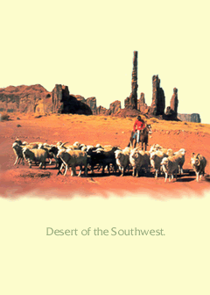
DINE LANDSCAPE
In their language, Dinè means "Children of God" and the word "Navajo" comes from a Spanish word meaning stealer. Their ancestral home is the desert of the American southwest. Dinè is the largest Indian Nation and today most Dinè live on the "big rez" which includes parts of Arizona, New Mexico and Utah.

DINE JEWLERY AND RUGS
Dinè jewlery and rugs are known around the world for their beauty and craftsmanship. Rugs are made on a loom. Often the jewelry is made with silver and turquoise.
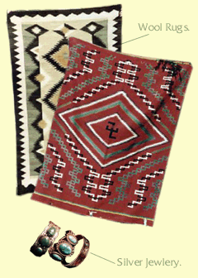
FOOD
Traditionally the Dinè farmed beans, squash and corn and hunted deer, pararie dogs and other animals. Corn was the most important food. Indian corn comes in many colors and could be eaten fresh or dried and ground. Today many raise sheep for meat and wool. Mutton (meat from sheep) and fry bread is a favorite food.
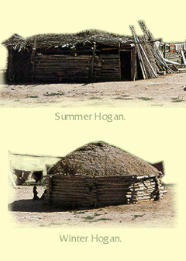

DINE HOGAN
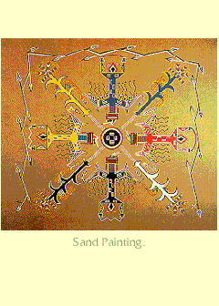
The traditional house is a "hogan." It has six or eight sides and made of logs, brush and mud. The door faces east towards the rising sun. While many Dinè live in modern houses some still live in hogans and say its nice to be together instead of in seperate rooms. Hogans are used for family ceremonies.

SAND PAINTING
Some Dinè believe that illness comes from harmful forces. Medicine men drive harm away with ceremonies that include song and sacred objects. Sometimes they make sand paintings. While people have access to doctors, they continue to seek medicine men. Western doctors are just now learning the importance of curing the spirit.

Dinè (Navajo) Information
- Dinè means "Children of God."
- "Navajo" comes from a Spanish word meaning "stealer."
- Their ancestral home is the desert of the American southwest.
- Dinè is the largest Indian Nation.
- Today, most Dinè live on the "big rez" which includes parts of Arizona, New Mexico, and Utah.
- The Dinè are known for creating beautiful silver and turquoise jewelry and wool rugs.
- Rugs are made on a loom.
- The Dinè originally farmed beans, squash, and corn and hunted deer, prairie dogs, and other animals.
- Corn was the most important food. Indian corn comes in many colors and could be eaten fresh or dried and ground.
- Today, many Dinè raise sheep for meat and wool.
- They eat mutton and fry bread.
- The traditional house is called a hogan.
- Hogans have six or eight sides and are made of logs, brush, and mud.
- The door of the hogan faces east towards the rising sun.
- Today, many Dinè live in modern houses, while some still live in hogans in order to live together rather than separately.
- Hogans are still used for family ceremonies.
- Some Dinè believe that illness comes from harmful forces and have medicine men get rid of the harm by performing ceremonies that include singing and sacred objects.
- Sometimes the medicine men make sand paintings as a way to get rid of the harm.
- Dinè now have access to doctors; however, some continue to use medicine men because Western doctors are just now learning the importance of curing the spirit.
- The Dinè, Dineh, or Navajo Nation is the largest Native nation in the United States, both in territory and population.
- Navajo Reservations are in Arizona and New Mexico and are held in trust by the United States Government.
- The population is approximately 165,000.
- Approximately twenty percent of the Dinè live off the reservation, many in urban areas.
- The name Dinè means "The People."
- Dinè women own sheep herds and produce very beautiful Navajo rugs.
Dinè men create beautiful works of art in turquoise and silver.
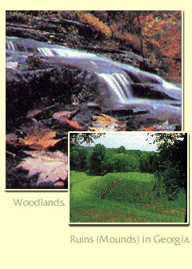
MUSCOGEE LANDSCAPE
The Europeans called the people "Creeks" because they built their villages near the creeks. They call themselves Muscogee. It comes from Maskoke, which was originally the name of a particular Creek band. Later, this name became used to refer to Creek people in general. Today, many people use the two words together: Muskogee Creek. Their ancestral home is the American southeast but because they were made to leave, today most Creek people live in Oklahoma.

MUSCOGEE CLOTHING
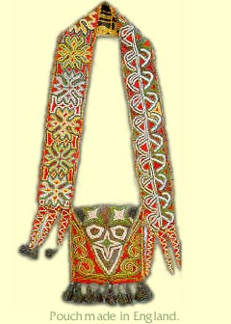
Prior to contact with Europeans the Muscogee wore few clothes. Men wore deerskin breechcloths and women wore skirts. As early as the 1700s, European traders introduced wool and cotton clothes made in England. The Muscogee adapted the clothing and traded deer pelts for it. Today Muscogee wear everyday American clothing.

MUSCOGEE FOOD
The men hunted deer while women knew where to go to gather nuts, wild onions and berries. They tended gardens full of corn, beans and squash and shared food with all. Corn was important food and women ground it into meal and made "sofkey.” Many people have a favorite recipe for sofkey and blue dumplings and mostly eat American foods.

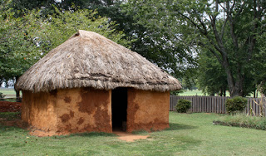
MUSCOGEE THATCH HOUSE
A typical village was built around the council house and a large field used for sports. The houses had thatched roofs. The towns looked different when the people were made to moved west. In the new territory most of the houses were made of log, some like the one pictured here was of wood.
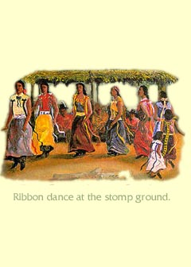
MUSCOGEE DANCE
Traditional Muscogee ceremonies take place at the stomp ground. An important celebration is the Green Corn Festival where people give thanks for the harvest. During the ceremony female dancers wear turtle shells or cans on their ankles and while they dance the shells and cans make music.

Muscogee (Creek) Information
- The Europeans called the Muscogee people "Creeks" because they built their villages near creeks.
- The people call themselves "Muscogee."
- Their ancestral home is the American southeast, in what is now Georgia.
- Because white settlers made them leave their original home, most Muscogee people now live in Oklahoma.
- Women traditionally wore skirts, and men wore deerskin breechcloths.
- In the 1700s, European traders introduced wool and cotton clothes made in England.
- The Muscogee adapted the European clothing and traded deer pelts for it.
- Today, Muscogee wear American clothing.
- Corn was an important food, which women ground into meal and boiled with lye to make "sofkey."
- For food, women gathered nuts, wild onions, and berries, and men hunted deer.
- Muscogee had gardens full of corn, beans, and squash.
- They shared the food among the group.
- Today, Muscogees mostly eat American foods.
- The Muscogee originally lived in houses with thatched roofs.
- A typical village was built around the council house and a large field used for sports.
- After the Muscogees were forced to move west, their towns and homes looked different.
- In the West, most of the houses were made of logs.
- Traditional Muscogee ceremonies take place at the stomp ground.
- An important celebration is the Green Corn Festival, when people give thanks for the harvest.
During the Green Corn ceremony, women dancers wear turtle shells or cans on their ankles to make music while they dance.

IROQUOIS CONFEDERACY
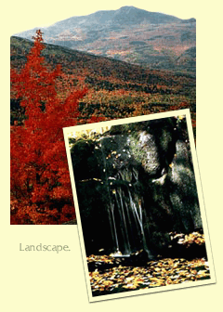
The name Iroquois means "rattlesnakes." They call themselves Haudenosaunee which means "people building a long house." They live in what is now the state of New York and parts of Canada. The Iroquois Confederacy originally included five nations and was a democracy. The US government is modeled on it.

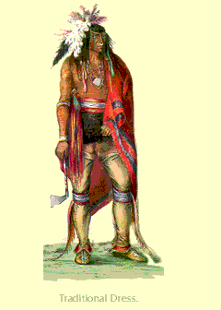
IROQUOIS CLOTHING
The Haudenosaunee (Iroquois) used European cloth and adapted it to their own style. This man wore feathers in his hair, a ring in his nose and other jewlery, a cape, a sash around his waist, breechcloth, leggings and moccosins.
Today they wear modern clothes like most Indian people.

FOOD
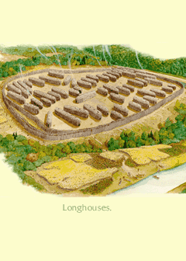
Before Europeans, the Iroquois were farmers, and hunters. The main crops were corn, beans, and squash and were considered special gifts from the Creator. The Haudenosaunee called them the "three sisters" and imagined them as beautiful women clothed in the plants.

IROQUOIS LONGHOUSE
The Haudenosaunee (Iroquois) people lived in villages and farmed. Their houses were called longhouses because they were longer than they were wide. The houses were made from elm bark. They had door openings at both ends and no doors or windows. During the winter, the doors would have been covered with skins.
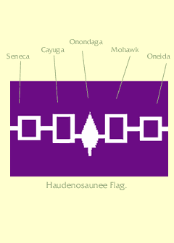
HAUDENOSAUNEE FLAG
The Haudenosaunee Flag represents the original five nations that were united in peace by the Peacemaker. The five nations includes: Seneca, Cayuga, Onondaga, Mohawk and Oneida. The pine tree symbol in the middle represents a White Pine. If you look at a White Pine you will notice that the needles are clustered in groups of five.

Haudenosaunee (Iroquois) Information
- The word Iroquois means "rattlesnakes."
- The Iroquois call themselves Haudenosaunee, which means "people building a long house."
- Iroquois live in what is now the state of New York and parts of Canada.
- The Iroquois Confederacy originally included five nations and was a democracy.
- The five nations include: Seneca, Cayuga, Onondaga, Mohawk, and Oneida.
- The pine tree symbol in the middle of the flag represents a White Pine because this tree's needles are clustered in groups of five.
- Onondaga - Keepers of the Fire, Capital of the Confederacy (currently they live near Syracuse, New York). Seneca - Keepers of the Western Door (currently they live in New York and Canada). Cayuga - Younger Brothers of the Seneca (currently they live near Buffalo, New York). Mohawk - Keepers of the Eastern Door (currently they live in New York and Canada). Oneida - Younger Brothers of the Mohawk (currently they live in Wisconsin and Canada).
- The U.S. government was modeled on the Iroquois nations.
- The Haudenosaunee (Iroquois) used European cloth and adapted it to their own style.
- Some men wore feathers in their hair, rings in their nose, and other jewelry.
- Men also wore capes, sashes around their waist, breechcloths, leggings, and moccasins.
- Today, the Iroquois wear modern clothes.
- Before the Europeans came, the Iroquois were farmers and hunters.
- The main crops were corn, beans, and squash, and these were known as the "sustainers of life" and were called the "Three Sisters."
- These three crops were considered special gifts from the Creator, and each was believed to be protected by one of the Three Sister Spirits.
- Legends were woven around the Three Sisters who would never be apart from one another, just as corn, beans, and squash were planted together, eaten together, and celebrated together.
- The Haudenosaunee (Iroquois) people lived in villages and farmed.
- Iroquois houses were called longhouses because they were longer than they were wide.
- The houses were made from elm bark.
- Longhouses had door openings at both ends and no doors or windows.
- During the winter, the doors were covered with skins.
The Haudenosaunee Flag represents the original five nations that were united in peace by the Peacemaker.

TLINGIT LANDSCAPE
The Tlingit live in the northwest in an area that is now part of Alaska. The land and sea provided plenty of food. The people traded and did business with Europeans and people of other tribes. They prospered and had time for many things. Their name for themselves means “People of the Tides.”

TLINGIT CLOTHES
Ceremonial dress includes carved masks, weapons and "Chilikat" robes. Some robes are fringed, fur-trimmed, and multicolored. The designs on clothing depict animals significant to the family and town.
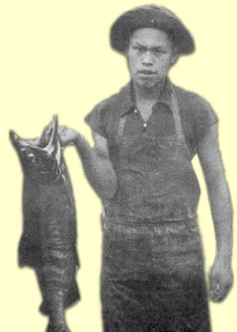
The Tinglit use to wear hats made of roots. Men and women wore ear and nose rings. Some had tattoos and disks pierced through their lower lip.

FOOD
Tlingit are master fishermen. They eat salmon, eulachon and halibut. The salmon is the most important. In the summer they enjoy wild berries. Traditionally they hunted and trapped animals like goats and deer and used canoes to hunt seals, sea lions and otters.

TLINGIT PLANK HOUSE
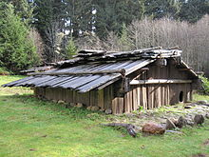
People live in towns with wood buildings. Some houses were painted and shaped like this one. Long ago families lived together. The houses had a hole in the roof to let smoke out, no windows and no rooms but partitioned sleeping and storage areas instead. Large items like fishing gear and paddles were stored in the rafters.

TOTEM POLES
Totem poles are carved from cedar trees, painted and placed near the house or in the forest. The Tlingit made them:
- Tell a family story or legend
- Honor the dead
- Commemorate a birth
- Make fun of someone

MEANING OF FIGURES
- Thunderbird - most powerful of all the spirits; it the personification of "chief."
- Wolf - revered as a good hunter and associated with the special spiritual necessary to become a good hunter.
- Killer Whale - legend says that whales could capture a canoe of people and drag it to an underwater village. Here people would be transformed into whales.
- Raven - A cultural hero of the Coast Indian peoples who had magical powers and could change himself into anything.
- Grizzly Bear - here it represents the clan of the people who made the totem pole. Attributed with many human-like qualities and much power.
HOW COLOR WAS MADE
- Red Iron oxide or red ochre clay
- Black Cedar and charcoal
- Blue-Green Copper or clay The three traditional colors are red, blue-green, and black. Paint was made from natural materials and mixed with salmon eggs

Tlingit Information
Tlingit live in the American Northwest Coast that is now part of Alaska.
- Food is provided by both land and sea.
- Originally traded and did business with Europeans and other Native American tribes.
- Ceremonial dress includes carved masks, weapons and "Chilikat" robes
- Chilikat robes may be fringed, fur-trimmed, and multicolored. The designs on clothing depict animals significant to the family and town.
- The Tinglit used to wear hats made of roots. Men and women wore ear and nose rings. Some had tattoos and disks pierced through their lower lip.
- Tlingit are master fishermen.
- They eat fish; most important is salmon.
- In the summer they eat wild berries.
- Tlingit traditionally hunted and trapped animals such as goats and deer, and used canoes to hunt seals, sea lions, and otters.
- Tlingit live in towns with wood buildings that are sometimes decoratively painted.
- Long ago families lived together.
- The houses had no windows but had a hole in the roof to let smoke out.
- Houses had no rooms but had partitioned sleeping and storage areas.
- Fishing gear, canoe paddles, and other large objects were stored in the rafters.
- The Tlingit made totem poles to tell a family story or legend, honor the dead, commemorate a birth, or make fun of someone.
Totem poles are carved from cedar trees, painted and placed near the house or in the forest.

http://www.ic-migration.webhost.uits.arizona.edu/icfiles/ic/kmartin/School/amer1.htm

