Examples of Ancient Athens Pottery:
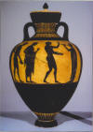 Example A: This is a Black-Figure vase dating to the mid fifth century B.C.E. It shows four men holding musical instruments including a double flute and a drum. This type of vase is called an amphora and was typically used to store grain, oil, and wine.
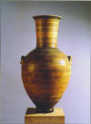 Example B: This is a Geometric vase dating to 760 B.C.E. The vase shows a stylized funeral scene in which funeral scene in which the deceased is lying down, surrounded by other human figures. This type of vase, called a funerary amphora, typically had a hole in the bottom so that relative of the deceased could place the vase on top of the grave and pour offerings of water or wine through the hole.
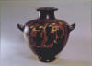 Example C: This is a Black-Figure vase dating to the late sixth or early fifth century B.C.E. The vase shows a woman drawing water at a fountain as the women behind her carry water jugs on their heads. This type of vase is called a hydria and was often used to hold water.
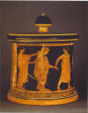 Example D: This is a Red-Figure vase dating to the fifth century B.C.E. It shows a groom leading a bride by the hand while another woman adjusts the bride's clothes. This type of vase is called a pynxis and was often used to store toilet articles such as women's cosmetics.
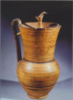 Example E: This is a Geometric vase dating to the late sixth century B.C.E. and measuring about 18 inches tall and 9 1/2 inches wide. This type of vase is called an oenochoe (pronounced EE-no-kee) and was typically used as a wine jug.
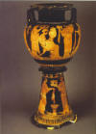 Example F: This is a Red-Figure vase dating tothe mid fifth century B.C.E. It shows several women presenting gifts to a bride on the day after her wedding. This type of vase is called a lebes gamikos and was a typical wedding gift for a wealthy bride. The bride, who is seated, holds a lebes gamikos on her lap.

